**Week 2**

**NAME:HASHIR KHAN**

**ID: TN/IN01/PY/007**

**DOMAIN:PYTHON**

**Step 1: Create Variables for Each User**

We’ll use simple variables to store data for each person.

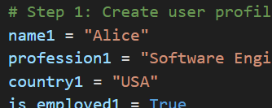

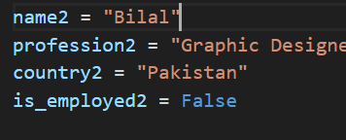

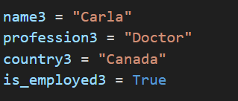

**Step 2:**

• f"" means we are using an **f-string** (formatting string).

• :<10 means “left-align this column and keep 10 spaces”.

• We use 10, 20, etc., to **keep columns aligned**.

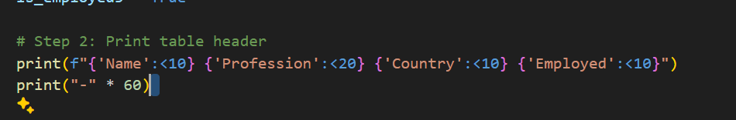

**Step 3:**

**Print User Data in Rows**

Each user gets a line like this:

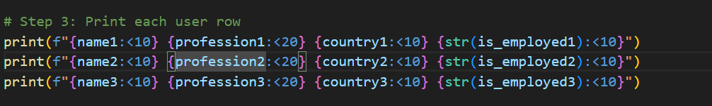

**OUTPUT**

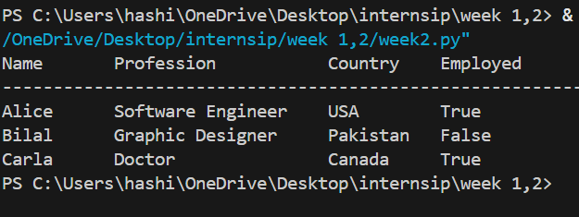

**Task 2**

**Step 1: Define User Information Using Variables**

**Just like we store information in labeled boxes, in Python, we use variables.**

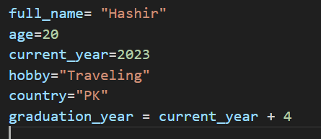

**Step 2: Calculate Expected Graduation Year**

**We assume the person will graduate after 4 years.**



**Step 3: Calculate Years Left Till Graduation**

**We want to calculate:**

**How many years are left till graduation?**



**Step 4: Print the Profile in Sentences**

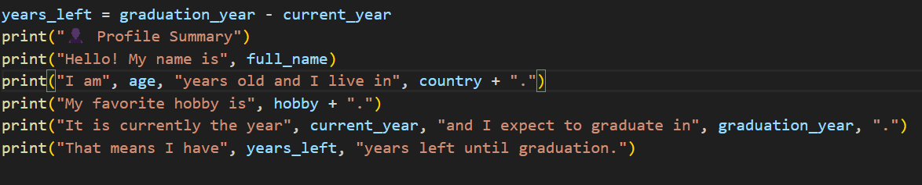

**OUTPUT**

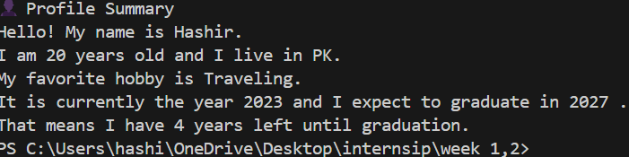

**Task 3**

**Step 1: Declare 5 Variables** 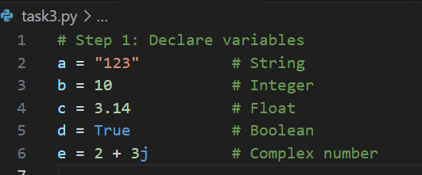

**Step 2: Print Values and Types**

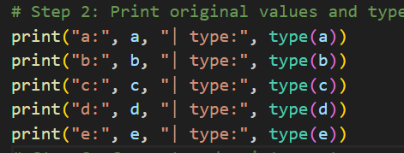

**Step 3: Try Converting Each Variable**

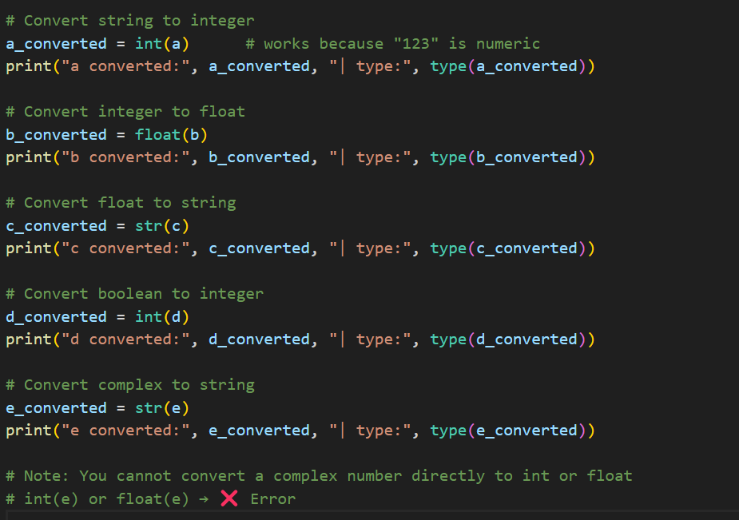

**Output**

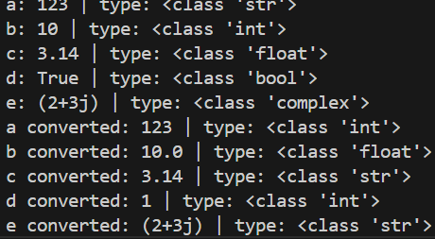

Task4

Step 1: Take input from the user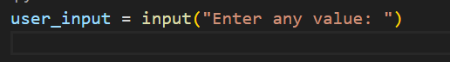

Step 2: Show what Python thinks the type is



Try to convert the input to an integer

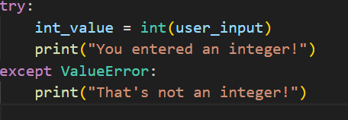

Step 4: If not int, try float

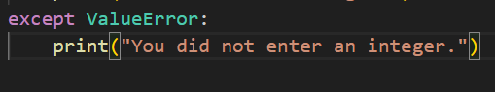

**Step 5: If both fail, it’s a string**

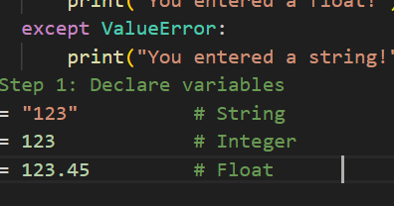`

Task 5

**Step 1: Asking Questions Using input()**

**input() is a Python function that asks the user to type something.**

**"What is your name?" is the message shown to the user.**

**Whatever the user types is stored in the variable name.**

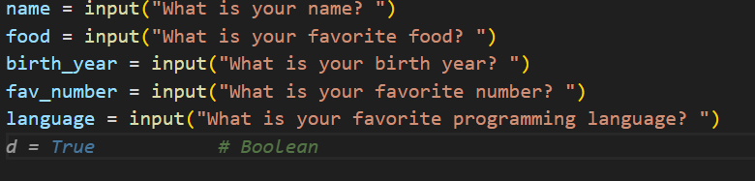

**Step 2: Neat Summary with Formatting**

**= is a character.**

**\* 30 repeats it 30 times to make a divider line like this:**

**\n adds a blank line before the summary.**

**This line prints a title: "📄 Survey Summary"**

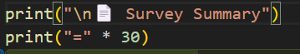

**Step 3: Print Each Answer with f-strings** 

**Step 4: Ending the Summary Thank the User**



Output

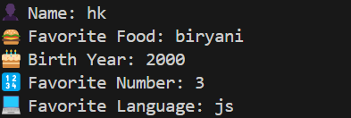

Task 6

Step 1: Take Year of Birth



* input() asks the user to type something.
* int() converts that input from string to **integer** (since year must be a number).

Step 2: Get the Current Year



• We import datetime to get the **current date and time**.

• .now().year extracts just the year (like 2025).

Step 3: Calculate Age



Step 4: Voting Eligibility Check 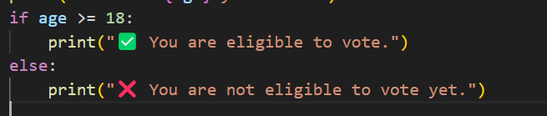

• If the user is 18 or older, they can vote.

• Otherwise, show that they’re not eligible yet.

Ouput

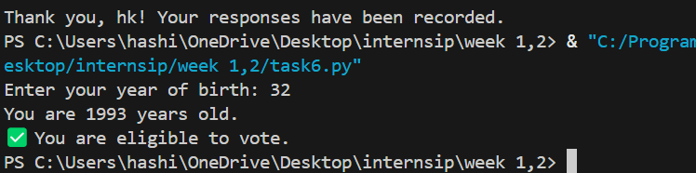

Task 7

Step 1: Take Inputs



• input() takes user input as a string.

• int() converts it to a number so we can do calculations.

Step 2: Total and Percentage

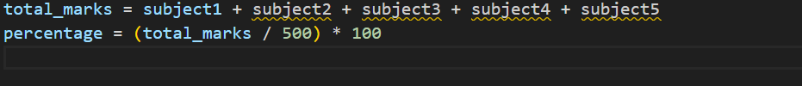

* Adds all subject marks.
* Divides by 500 (total possible marks) and multiplies by 100 to get percentage.

Step 3: Assign Grade

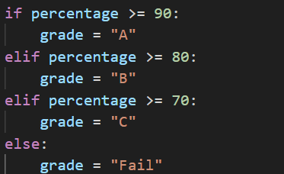

Step 4: Print Results



Output

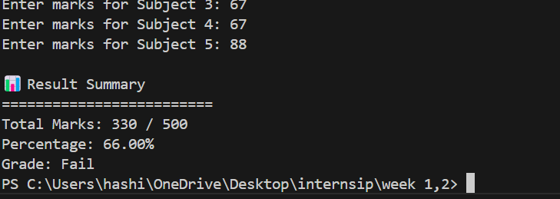

Task 8

**Step 1: Celsius to Fahrenheit** 

• input() gets user input.

• float() converts it into a number with decimal support.

• If the user types a letter or word, it raises a ValueError, which is caught by try-except.

Step 2: Fahrenheit to Celsius



**Step 3: Error Handling with try-except** 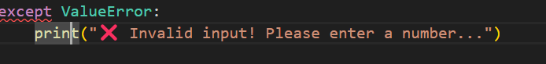

Output

